Ports and Waterways Safety Assessment
Port of Tampa
May 15th & 16th, 2024
1100 Channelside Drive, Tampa, Fl 33602
Port Tampa Bay Boardroom
Workshop Agenda
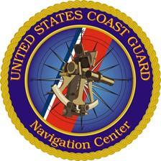
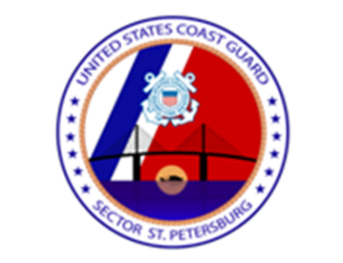
Day One:
0800 – 0815 Introductions: Sponsor/COTP Sector Saint Petersburg & U.S. Coast Guard Navigation Center.
0815 – 0915 Introductions: Stakeholder Participants.
0915 – 1000 Workshop Overview:
- Background
- Methodology.
- Collectively Establish “Ground Rules”.
1000 – 1200 Discuss Survey Baseline Risk and Risk Characterization:
(10-minute breaks after each step).

1. Navigation Conditions – environmental conditions that vessels encounter: Winds, currents & tides, visibility restrictions, bottom type.

2. Vessel Conditions – quality of vessels and crews operating in waterway/port: Large commercial vessels, small commercial vessels, commercial fishing, recreational vessels.
3. Traffic Conditions – number of vessels that use a waterway and how they interact: Volume of commercial traffic, volume of recreational traffic, waterway use, congestion.
4. Waterway Conditions – physical properties that affect vessel maneuverability: Dimensions, obstructions, visibility impediments, configuration.

1200 – 1300 Break for Lunch
1300 – 1600 Continue Baseline Risk Survey and Risk Characterization:
- Resolve Tabled Topics, Day One Exit Survey & Wrap-up.

Day Two:
0800 – 0830 Review Workshop & Resolve Outstanding Topics.
0830 – 0845 Baseline Risk Results – generated by Day One team surveys.
0845 – 0930 Prioritize Top Risks – facilitated group discussion & consensus.
0930 – 1100 Establish Risk Mitigation Goals for Top Risks.
1100 – 1200 Break for Lunch
1200 – 1500 Continue Mitigation Discussion & Goals Consensus.
1500 – 1600 Workshop Wrap-up:
- Feedback Survey.
- Post-PAWSA Actions.
- Closing Remarks: Sector Saint Petersburg Chief of Prevention.

